**Deploy static page through S3 Bucket on AWS**

**Step 1 :-** **create S3 bucket**

* Login to aws consol.
* Select the your nearest regions **like :-** **[Asia Pacific (Mumbai)ap-south-1](https://ap-south-1.console.aws.amazon.com/console/home?region=ap-south-1)**
* Go to service and search S3 option and then click on it.

**Note:-** create S3 bucket name with the same name of your domain

* Click on “create bucket” button for creating S3 bucket.
* After creating S3 then click on his name and click “upload” button and upload your index.html file

**Step 2 :-** **Configurations S3 bucket**

* After upload static files then click on the name of your S3 bucket name.
* Click on “Properties” menu bar and click on “Edit” button on Static Website Hosting.
* Then after do this

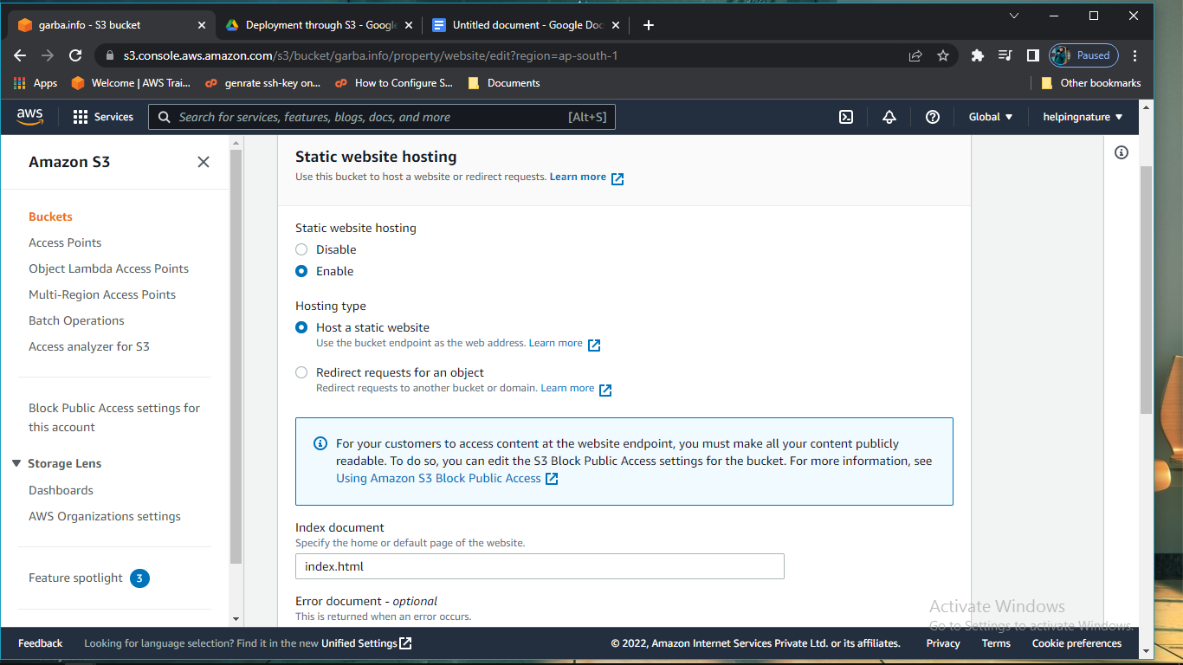

* After doing this click on “save changes” button.
* Click on “Permissions” menu bar and check your file is access public or not, if your file is not public then you do public access.
* Then go to Bucket Policy option in Permissions menu bar.
* Coming to the bucket policy and write the JSON code like this:-

{

"Version": "2012-10-17",

"Statement": [

{

"Sid": "PublicRead",

"Effect": "Allow",

"Principal": "*",

"Action": [

"s3:GetObject",

"s3:GetObjectVersion"

],

"Resource": "arn:aws:s3:::garba.info/*"

}

]

}

**Note:-** change garba.info name of according to your domain name

**Step 3 :-** **Create Route 53**

* Go to services and search route 53 and click on it.
* Then click on “DNS Management” optins.
* Then click on “create hosted Zone” button.
* After creating hosted Zone you got DNS name server like:-

ns-1050.awsdns-03.org.

ns-485.awsdns-60.com.

ns-611.awsdns-12.net.

Ns-1591.awsdns-06.co.uk. **Note:-** Do not Edit/delete default name server name

**Step 4 :-** **Setup DNS name server on GoDaddy**

* Go to Godaddy and selete your domain name go to his DNS manage option
* Then replace DNS name server
* Write aws DNS name server in GoDaddy.

**Note:-** It takes a maximum of 24 hours for the name server to be set up

* When you replace DNS name server then remove last (.) dot like :-

ns-1050.awsdns-03.org

ns-485.awsdns-60.com

ns-611.awsdns-12.net

Ns-1591.awsdns-06.co.uk

**Step 5 :- Create Record Set in Route 53**

* Go to again your Hosted Zone and click on “create record” button.
* Then fill up details like this:-

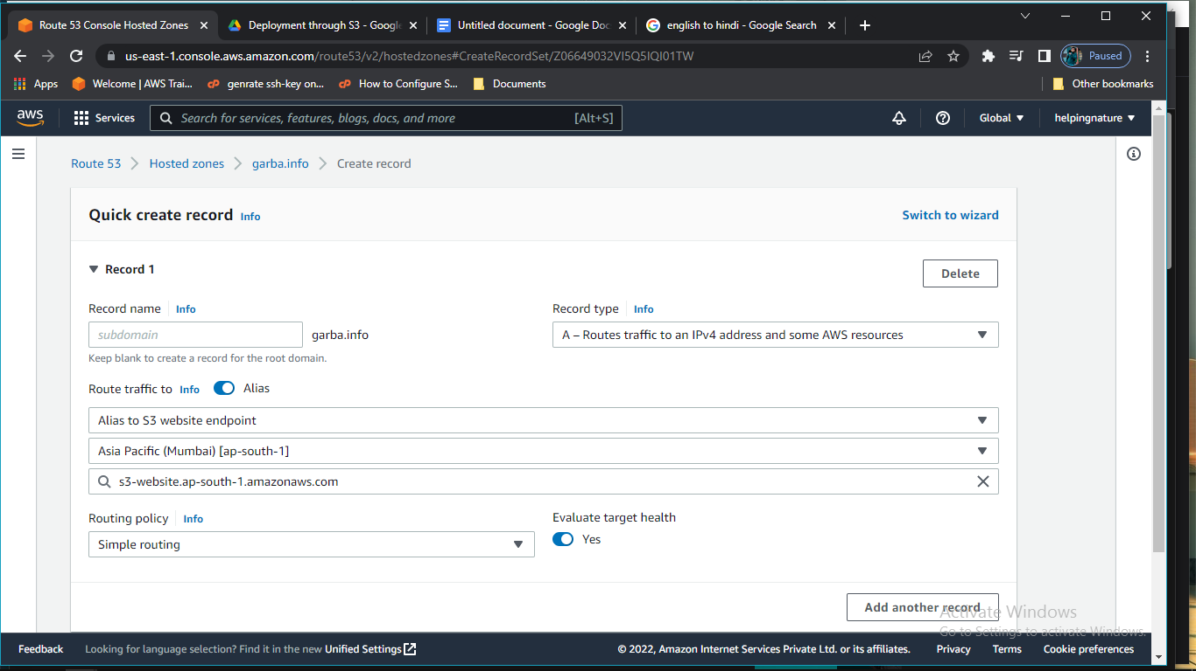

* After fill up details click on “create records” button.

After completing all steps then your page is live now